PROJECT REPORT
ELECTRIC VEHICLE MARKET
PERFORMANCE & INSIGHTS
EV Market Analysis Using Python, Snowflake and Tableau

Project Information | Details
Student Name | Soumil Jaiswal
Team ID
Project Name | Electric Vehicle Market Performance & insights
Date | 1 November 2026

Prepared as an individual project report

1. INTRODUCTION

1.1 Project Overview
Electric Vehicle Market Performance & Insights is a data analytics project that explores electric-vehicle market information through data preparation, SQL-based analysis and interactive visualization. Python and Pandas are used for data inspection and cleaning, Snowflake for cloud-based data storage and querying, and Tableau for dashboards and data storytelling.
The dashboard focuses on manufacturer-wise annual sales, market-region and vehicle-category patterns, sales trends over time, average vehicle prices, and the relationship between vehicle price and driving range. A Tableau Story named “EV_Market_story” organizes selected views into a guided sequence.

1.2 Purpose
- Convert raw EV market data into a structured, analysis-ready dataset.
- Compare annual sales performance across manufacturers and vehicle categories.
- Explore category performance across market regions.
- Understand yearly sales patterns and average-price differences.
- Compare vehicle price and driving range using visual analysis.
- Present findings through a dashboard and Tableau Story.

2. IDEATION PHASE

2.1 Problem Statement
EV market information can be difficult to interpret when it is stored in large tables or spread across fields such as manufacturer, category, region, sales, price and range. Manual comparison makes it harder to identify leading manufacturers, category-level patterns and relationships between price and driving range. This project addresses the problem by preparing the data and presenting it through an integrated analytical dashboard.

2.2 Empathy Map Canvas
Empathy Area | User Perspective
Says | “I need a clear way to compare EV manufacturers, categories, sales and vehicle range.”
Thinks | Which manufacturers perform well? Which categories and regions show stronger market activity?
Does | Reviews datasets, applies filters, compares charts and explores market reports.
Feels | May feel overwhelmed by large datasets; feels more confident when insights are visualized.
Pains | Manual comparison, inconsistent data, large tables and difficulty finding relevant trends.
Gains | A unified view, faster comparisons and clearer evidence for market analysis.

2.3 Brainstorming
- Use Python/Pandas to inspect and clean the raw EV dataset.
- Load prepared data into Snowflake for structured storage and SQL analysis.
- Create manufacturer-wise sales and category-wise comparisons.
- Use a heatmap to compare vehicle categories across market regions.
- Use a line chart to show yearly sales trends.
- Use a scatter plot to compare vehicle price with driving range.
- Create a Tableau Story to guide users through the main market views.

3. REQUIREMENT ANALYSIS

3.1 Customer Journey Map
Journey Stage | User Actions | Touchpoints | User Need / Outcome
Discover & Explore | Open dashboard and review available views. | Dashboard overview, story tabs. | Understand dashboard coverage.
Analyze & Interact | Compare manufacturers, categories, regions, sales, price and range. | Filters, bar charts, heatmap, line and scatter plots. | Find patterns and compare data.
Gain Insights & Decide | Review findings and interpret market performance. | Dashboard summaries and Tableau Story. | Use evidence to support market understanding.

3.2 Solution Requirement

Functional Requirements
- Import the EV dataset and inspect its structure and fields.
- Check missing values, duplicate records and inconsistent text values.
- Store and query structured data in Snowflake.
- Calculate or aggregate sales and price metrics where required.
- Build Tableau visualizations for manufacturer, category, region, year, price and range analysis.
- Provide interactive filters where configured.
- Arrange selected visualizations in a Tableau Story.

Non-Functional Requirements
- Maintain data accuracy and consistency after preprocessing.
- Use readable chart labels, legends and dashboard layouts.
- Maintain reasonable query and dashboard response time.
- Protect database credentials and access permissions.
- Keep code, SQL queries and dashboard structure maintainable.

3.3 Data Flow Diagram
EV Dataset (CSV)
↓
Python / Pandas – Inspection and Cleaning
↓
Snowflake – Data Storage and SQL Analysis
↓
Tableau – Data Connection and Visualization
↓
Interactive Dashboard and EV_Market_story
↓
Market Insights and Interpretation
Input: EV market records. Processing: data quality checks, cleaning, standardization and SQL analysis. Output: charts, dashboard views and a guided story.

3.4 Technology Stack
Technology | Role in the Project
Python | Data inspection, cleaning and preparation.
Pandas | Tabular data manipulation and quality checks.
Snowflake | Cloud data warehouse for storing and querying the EV dataset.
SQL | Filtering, aggregation, grouping and analytical queries.
Tableau | Interactive charts, filters, dashboards and data storytelling.
CSV | Dataset file format used for data input.

4. PROJECT DESIGN

4.1 Problem–Solution Fit
Canvas Element | Project Fit
Customer Segments | EV market analysts, automotive business teams, manufacturers, researchers and decision-makers.
Jobs / Problems | Compare manufacturers, understand category and regional sales, review yearly trends, and examine price versus range.
Triggers | Market research, business planning, manufacturer comparison and review of EV market performance.
Pain Points | Large datasets, scattered information, time-consuming manual comparisons and difficulty spotting patterns.
Existing Alternatives | Spreadsheets, static reports, manufacturer websites and separate market research sources.
Proposed Solution | Python, Snowflake and Tableau workflow to prepare, query and visualize EV market data.
Channels | Tableau dashboard, Tableau Story, project demonstration and report.

4.2 Proposed Solution
The proposed solution is a centralized EV market analysis workflow. Python and Pandas inspect and prepare the dataset. Snowflake provides a structured environment for storing and querying the data. Tableau presents the analysis through visualizations and a story sequence.
- Horizontal bar chart – annual sales by manufacturer.
- Heatmap – vehicle category performance across market regions.
- Stacked bar chart – annual sales by manufacturer and category.
- Line chart – sales trend by year.
- Bar chart – average price by vehicle category.
- Scatter plot – vehicle price versus driving range.
- Pie chart – vehicle category distribution.
The Tableau Story, “EV_Market_story”, includes Global EV Manufacturing, Manufacturing Density, Market Breakdown, Manufacturing Leaders, and Price vs. Range Dynamics.

4.3 Solution Architecture
Layer | Component | Responsibility
Input Layer | EV CSV dataset | Provides source records.
Preparation Layer | Python and Pandas | Inspects, cleans and standardizes data.
Storage / Query Layer | Snowflake and SQL | Stores structured data and performs analytical queries.
Visualization Layer | Tableau | Creates charts, filters, dashboards and story points.
Presentation Layer | Dashboard and report | Communicates findings to users.

5. PROJECT PLANNING & SCHEDULING

5.1 Project Planning
Phase | Main Activities | Deliverable
1. Understand the Problem | Define analysis goals and identify key EV market questions. | Problem statement and objectives.
2. Dataset Preparation | Load CSV, inspect columns, check missing values and duplicates, and clean fields. | Prepared dataset.
3. Data Storage and Analysis | Load data into Snowflake and write SQL queries for comparisons and aggregations. | Structured data and query outputs.
4. Visualization Development | Build charts for manufacturers, regions, categories, yearly sales, price and range. | Tableau worksheets and dashboard.
5. Story Development | Arrange story points to communicate findings in sequence. | EV_Market_story.
6. Testing and Documentation | Check chart values, filters, labels, data consistency and document outputs. | Tested project and report.

Individual project responsibility: The project work is carried out independently. Planning, data preparation, analysis, dashboard development, testing and documentation are managed by the project author.

6. FUNCTIONAL AND PERFORMANCE TESTING

6.1 Performance Testing
Testing checks whether the dataset is loaded correctly, preprocessing steps are applied, visualizations display the intended measures, and dashboard interactions work as expected.
S.No. | Parameter | Testing / Evidence to Record
1 | Data Rendered | Record Snowflake table name, actual row count and table size.
2 | Data Preprocessing | Record NULL checks, duplicate checks, trimming, standardization and cleaning results.
3 | Utilization of Filters | Test each configured filter, such as manufacturer, category, market region or year.
4 | Calculation Fields Used | List only calculated fields actually created in Tableau or SQL, with formulas.
5 | Dashboard Design | Verify the seven chart types and check titles, legends and labels.
6 | Story Design | Verify the five story sections and confirm each story point opens correctly.

For final submission, insert actual Snowflake row counts, query timings, calculated-field names and filter test results. Do not estimate or invent test values.

7. RESULTS

7.1 Output Screenshots
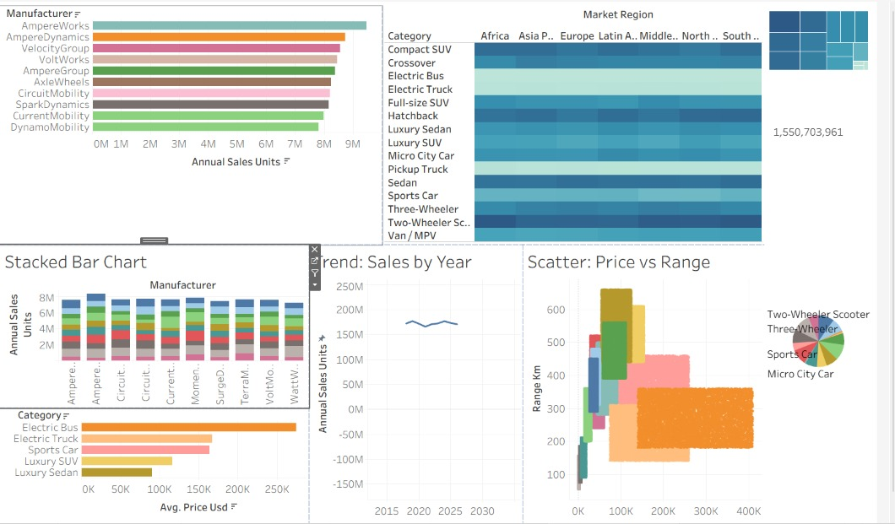
Insert actual screenshots captured from the completed work in the following order. Use clear captions and ensure chart labels and values are readable.
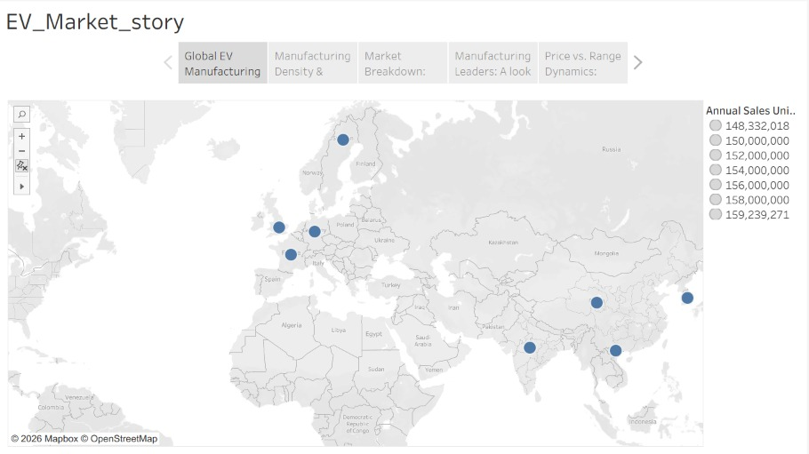
- Python data inspection and preprocessing output.
- Snowflake table showing the loaded EV dataset and record count.
- SQL query output for manufacturer-wise or category-wise analysis.
- Tableau dashboard showing manufacturer sales, regional heatmap, stacked bar chart, yearly sales trend, average price, price-versus-range scatter plot and category distribution.
- Tableau Story – EV_Market_story, showing the Global EV Manufacturing map and story navigation tabs.
- Additional story screenshots for Manufacturing Density, Market Breakdown, Manufacturing Leaders and Price vs. Range Dynamics, if available.

Key Observations
- The manufacturer bar chart shows differences in annual sales across displayed manufacturers.
- The regional heatmap compares EV category performance across market regions.
- The stacked bar chart compares manufacturer sales across vehicle categories.
- The yearly sales line chart provides a view of sales movement over time.
- The average-price chart compares pricing across selected EV categories.
- The scatter plot helps examine the relationship between vehicle price and driving range.
- The pie chart presents the distribution of displayed vehicle categories.
- The Tableau Story organizes global manufacturing and market analysis into a guided sequence.
Use exact values from dashboard tooltips or source data when adding numerical findings. The supplied screenshot does not provide every chart value.

8. ADVANTAGES & DISADVANTAGES

Advantages
- Combines data preparation, cloud data storage and visualization in one workflow.
- Makes manufacturer and vehicle-category comparisons easier.
- Presents regional patterns through a heatmap.
- Uses multiple chart types to explore different aspects of EV market performance.
- Interactive Tableau views can support focused data exploration when filters are configured.
- The Tableau Story helps present findings in a logical sequence.

Disadvantages / Limitations
- Insights depend on the completeness, accuracy and date coverage of the source dataset.
- A static or periodically refreshed dataset may not represent real-time market conditions.
- The dashboard describes patterns in the available data; it does not by itself prove why those patterns occur.
- Large datasets or complex visualizations may require query and dashboard optimization.
- Predictive forecasting and automated recommendations are outside the current scope unless separately implemented.

9. CONCLUSION
The Electric Vehicle Market Performance & Insights project demonstrates how data analytics tools can prepare, query and visualize EV market information. Python and Pandas support data preparation, Snowflake supports structured storage and SQL analysis, and Tableau communicates results through charts, an interactive dashboard and a Tableau Story. The project provides a clear way to explore manufacturer sales, regional category patterns, yearly trends, vehicle pricing and driving range, and establishes a foundation for further EV market analysis.

10. FUTURE SCOPE
- Connect additional and regularly updated EV datasets to improve market coverage.
- Add more detailed country, manufacturer and vehicle-model comparisons.
- Introduce forecasting models for sales trends after collecting suitable historical data.
- Optimize dashboard performance through efficient SQL, extracts or aggregated tables where appropriate.
- Improve usability with additional filters, tooltips and mobile-friendly layouts.
- Add exportable reports and scheduled refreshes where supported by the selected platforms.
- Strengthen access management and credential handling for shared or deployed environments.

11. APPENDIX

A. Source Code (Illustrative)
Python – basic data inspection and cleaning example:
import pandas as pd
df = pd.read_csv("EV_market_train.csv")
print(df.shape)
print(df.isnull().sum())
print("Duplicates:", df.duplicated().sum())
df = df.drop_duplicates()
df.to_csv("ev_cleaned.csv", index=False)
SQL – example manufacturer sales aggregation. Replace table and column names with the actual Snowflake schema:
SELECT MANUFACTURER,
SUM(ANNUAL_SALES_UNITS) AS TOTAL_SALES
FROM EV_MARKET_TRAIN
GROUP BY MANUFACTURER
ORDER BY TOTAL_SALES DESC;

B. Dataset Link
Dataset file / source URL: [https://www.kaggle.com/datasets/tharishreddy22/electric-vehicle-market-classification-dataset]

C. GitHub & Project Demo Link
GitHub repository: [Insert repository URL, if available]
Tableau Public dashboard / project demo: [https://public.tableau.com/app/profile/soumil.jaiswal/viz/Ev_Market_Performance/EV_Market_Dashboard?publish=yes]
Tableau Story link: [https://public.tableau.com/app/profile/soumil.jaiswal/viz/Ev_Market_Performance/EV_Market_story?publish=yes]

